**FLOOD MONITORING AND EARLY WARNING**

**OBJECTIVES:**

Flood monitoring and early warning systems are designed with multiple objectives: detecting potential flood events early by tracking various indicators, assessing the risk, developing effective communication channels to alert populations, preparing timely responses, minimizing the impact on lives and infrastructure, and continuously improving these systems. The core aim is to save lives, reduce damage, and enhance the resilience of communities in the face of flooding events.

**INTRODUCTION:**

Flood monitoring and early warning systems are critical in detecting and predicting potential flooding events, enabling timely responses to reduce the impact on communities. These systems involve various technologies like sensors, satellite imagery, and weather forecasting to gather data on water levels, rainfall, and river discharge. They help in issuing alerts, allowing authorities to take preventive actions, evacuate affected areas, and minimize the damage caused by floods.

**IOT SENSOR DEPLOYMENT:**

The deployment of IoT (Internet of Things) sensors involves strategically situating these devices in various locations to collect real-time data. These sensors can be placed in critical areas prone to floods, such as riverbanks, urban areas, or regions with a history of flooding. They collect information on factors like water levels, weather conditions, and soil moisture, transmitting this data wirelessly to a central system. This information aids in early detection, risk assessment, and timely warnings, allowing for effective flood monitoring and response planning

**TOOLS AND TECHNOLOGIES :**

**WEATHER RADAR:**

Doppler radar systems can detect precipitation intensity and movement, helping forecasters monitor rainfall patterns that can lead to flooding.

**SATELLITE IMAGERY:**

Remote sensing satellites, like those from NOAA and NASA, provide valuable data for monitoring weather patterns, identifying storm systems, and observing flood events.

**RAIN GAGUES:**

These instruments measure rainfall at specific locations, helping to assess the amount of rainfall in real time.

**RIVER AND WATER LEVEL SENSORS:**

Automated sensors placed along rivers and streams measure water levels continuously, providing data for flood prediction.

**METEOROLOGICAL STATION:**

Weather stations collect data on temperature, humidity, wind speed, and atmospheric pressure, which is crucial for forecasting flood conditions.

**HYDROLOGICAL MODELS:**

Software tools that simulate the behavior of river basins and watersheds, aiding in the prediction of water flow and flooding.

**EARLY WARNING SYSTEM:**

Integrated systems that process data from various sources and issue alerts to authorities and the public. These systems can use sirens, SMS, mobile apps, and social media for dissemination.

**GEOGRAPHIC INFORMATION SYSTEMS:**

GIS software helps in mapping flood-prone areas, visualizing data, and managing information related to flood monitoring.

**PLATFORM DEVELOPMENT:**

Platform development in the context of flood monitoring typically involves creating an integrated system or software that aggregates, analyzes, and visualizes data collected from various IoT sensors and other sources. These platforms often include a user interface for data visualization, predictive modeling, and decision-making support. They are designed to process real-time information, provide alerts, and offer tools for authorities and the public to access and interpret the data easily. Platform development aims to centralize information, enhance data-driven decision-making, and facilitate effective flood monitoring and early warning system

**IDEA FOR THE SOLUTION:**

**WEATHER AND RAINFALL MONITORING :**

Utilize weather stations and radar systems to continuously monitor weather conditions, especially rainfall. Data from these sources can help predict heavy rainfall and potential flood events.

**RIVER AND WATER LEVEL SENSORS:**

Install sensors along rivers, streams, and flood-prone areas to monitor water levels. These sensors should provide real-time data to assess rising water levels.

**SATELLITE IMAGERY:**

Incorporate satellite imagery to track weather patterns, cloud cover, and flooding in remote or inaccessible areas.

**MACHINE LEARNING ALGORITHMS:**

Develop predictive models using historical weather and flood data. Machine learning can help predict flood risks and issue warnings in advance.

**EARLY WARNING SYSTEM:**

Implement a multi-tiered warning system that sends alerts to the public through SMS, mobile apps, and sirens. Different warning levels can be triggered based on the severity of the flood threat.

**COMMUNITY ENGAGEMENT:**

Educate and involve local communities in the monitoring and response process. Encourage them to report local observations and participate in evacuation drills.

**EMERGENCY RESPONSE COORDINATION:**

Establish a coordination center that brings together government agencies, first responders, and NGOs to manage flood responses effectively.

**DRONE TECHNOLOGY:**

Employ drones for aerial surveys during floods to assess damage, locate trapped individuals, and plan rescue operations.

**EVACUATION PLANS:**

Develop and communicate evacuation plans, routes, and shelters to the public. Ensure that vulnerable populations are identified and assisted in evacuating.

**INFRASTRUCTURE RESILIENCE:**

Invest in flood-resistant infrastructure and urban planning to mitigate flood damage. This includes levees, flood walls, and sustainable land use.

**DATA VISUALIZATION TOOLS:**

Create user-friendly tools that display real-time flood data, weather forecasts, and evacuation routes to help individuals make informed decisions.

**CROSS-AGENCY COLLABORATION:**

Encourage collaboration between meteorological agencies, environmental departments, and disaster management authorities to ensure a unified approach to flood monitoring and response.

**RESEARCH AND DEVELOPMENT:**

Continuously invest in research to improve flood prediction models and early warning systems.

**COMMUNITY TRAINING:**

Conduct regular training for emergency responders and volunteers to ensure a swift and coordinated response during flood events.

**FEEDBACK MECHANISM:**

Establish a feedback system to gather information from the public on the effectiveness of flood warnings and response efforts, allowing for continuous improvement.

**IOT SENSOR:**

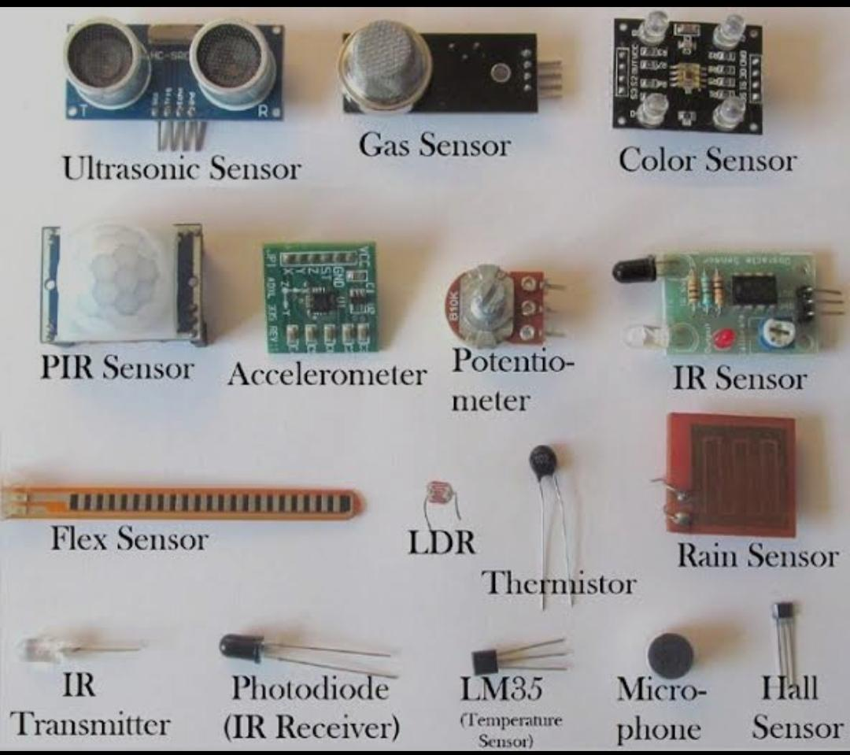

**ALGORITHM:**

Step1: Import the library packages and modules

Step2: Load the datasets

Step3: Exploring the dataset

Step4: Basic data analysis

Step5: Segregate the dataset

Step6: Visualize among segmentation of the dataset**.**

**FLOWCHART:**

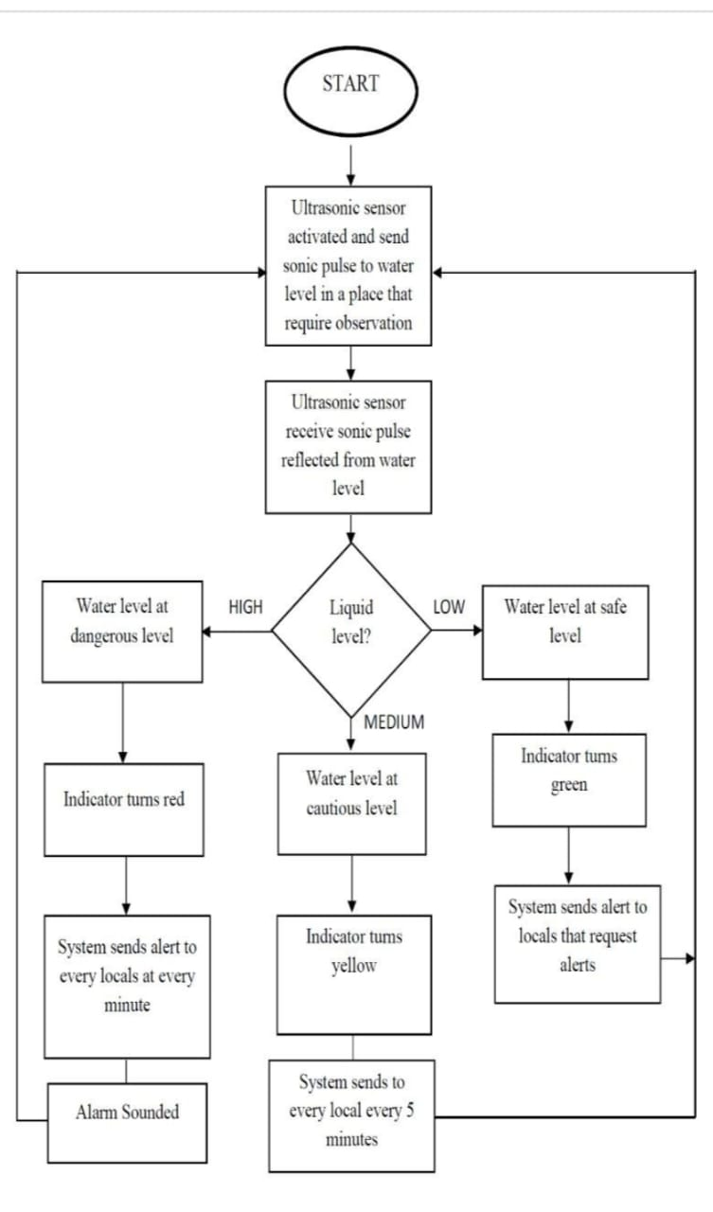

**BLOCK DIAGRAM:**

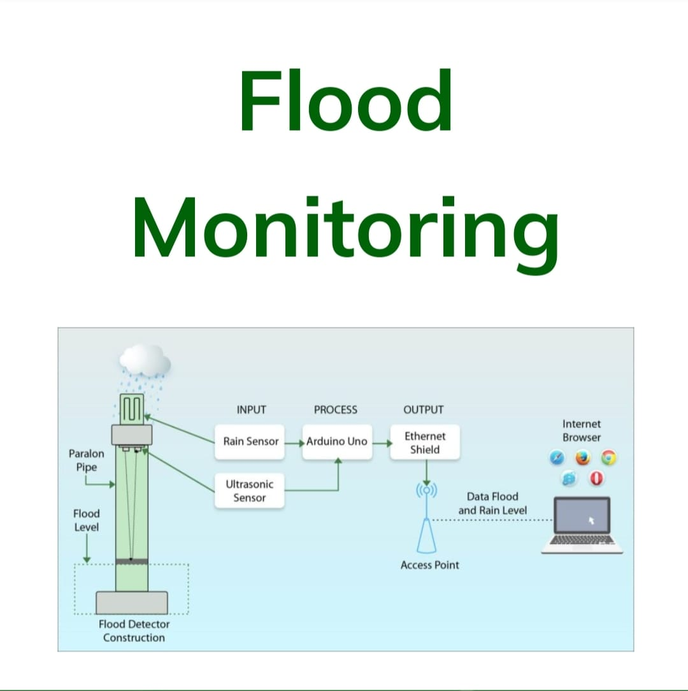

**PROGRAM:**

**# Import necessary libraries**

**import requests**

**import time**

**def check_water_level():**

**# Simulating API request to get water level data**

**# Replace 'API_ENDPOINT' with the actual API endpoint providing water level data**

**response = requests.get('API_ENDPOINT')**

**if response.status_code == 200:**

**water_level = response.json()['water_level']**

**return water_level**

**else:**

**print("Failed to retrieve data")**

**return None**

**def send_warning_notification(water_level):**

**# Simulate sending a warning notification if water level exceeds a certain threshold**

**if water_level > 5.0: # Replace 5.0 with the threshold level**

**# Replace with your notification method (email, SMS, etc.)**

**print(f"Alert: Water level is {water_level}. Potential flood warning!")**

**# Main function to continuously monitor**

**def monitor_water_level():**

**while True:**

**water_level = check_water_level()**

**if water_level is not None:**

**send_warning_notification(water_level)**

**# Check water level every 5 minutes (300 seconds)**

**time.sleep(300)**

**monitor_water_level()**

**CONCLUSION:**

In Flood monitoring and early warning systems play a pivotal role in safeguarding communities from the destructive forces of floods. By providing timely information, these systems enable proactive measures such as evacuation planning, risk reduction, and protection of critical infrastructure. The ultimate goal is to minimize the economic and human losses associated with flooding events. Continuous investment and advancements in technology are essential to ensure the effectiveness of these systems, thereby enhancing overall flood resilience and the safety of vulnerable populations.

**THANK YOU GUIDE FOR NAAN MUDHALVAN TEAM & IBM**